**METHODS**

**Data Preparation**

*Harbor Seal counts* – Adult and pup counts were the maximum count recorded between day 105 and 140 of each year. Molt counts were after day 155 of each year. Thus a single maximum count for each age class at each of the 6 sites was obtained for analysis for each year from 1997-2023. There was no molt count data for one site (Bolinas Lagoon: BL) in the first year (1997) and while our MARSS time series methods do allow for missing data, starting a time series with a missing data point can be problematic (Holmes et al. 2023). Therefore, we used the 1999 data value from the same site (since 1998 was an ENSO year). Four of six sites were missing count data in 2020, and these values were thus estimated by the MARSS model.

**Hypotheses and Covariates**

***Site Specific Covariates***

*Anthropogenic Disturbance* was calculated as the site-specific number of surveys per year with observed human disturbances and coded to only effect seal counts at the same site. We predicted that higher levels of human disturbance would result in lower counts of all age classes (CITE).

*Coyote Impacts* were calculated as the weighted average of site-specific surveys per year with coyote observations because we hypothesized that coyote presence in previous years would impact seal site use in year t. Thus, we calculated the coyote effect on seal counts in year t as (0.5rt + 0.3rt-1 + 0.2rt-2) / 3, where r is the rate of coyote observations per survey by site and year. Coyote disturbance was coded to only effect seal counts at the same site. We predicted that higher levels of coyote presence would result in lower counts of all age classes (CITE).

*Immature Elephant Seals –* The elephant seal population in the region has expanded from 1980 and a major colony is adjacent to our harbor seal colonies. We therefore included the annual maximum counts of immature elephant seals. There is little evidence for prey or haul out site competition (CITE), nonetheless, there could be poorly understood in water interactions since both immatures elephant seals and harbor seals use nearshore habitat, although elephant seals are believed to have minimal, if any impact on local prey populations (CITE). This covariate was coded to only influence locations near the elephant seal colony (DE, DP, and PRH).

***Regional Covariate***

*Ocean Conditions –* We used theCalifornia Multivariate Ocean Climate Indicator (MOCI) (García-Reyes and Sydeman 2016) as an index of ocean conditions. The index integrates information from several climate indicators (Multivariate ENSO Index, Pacific Decadal Oscillation, North Pacific Gyre Oscillation, Northern Oscillation Index, Coastal Upwelling Index, coastal sea level, along shore wind stress, sea surface temperature, sea air temperature, and sea level pressure) to develop principal components which predict the biological patterns of nearly 39 of 50 biological ocean time series tested by García-Reyes and Sydeman (2016). Importantly, this predicted population parameters in both upper trophic level predators such sea lions, seabirds and their prey (rockfishes, zooplankton, salmon). The MOCI is calculated quarterly for Southern, Central, and Northern California. For this study, we averaged the central and northern indices since the dividing line spans our study area. Based on the biology of harbor seals.

We included three different MOCI quarterly indices in our models that could affect different seal classes. Winter *MOCIJanuary-February-March*of year t was predicted to influence the winter build-up of the food web benefitting reproduction and seal presence for all classes (Adult, Pup, Molt). Previous year’s Fall *MOCIOctober-November-December* describes the ocean conditions during female egg implantation and was predicted to be related to pup and adult (not molt) counts in year t. *Last, the previous spring MOCIMarch-April-May* describes the previous year’s pupping season and may impact all age classes in year t.

The above covariates and hypotheses are represented graphically in Fig 2. Pup counts from covariates are mediated through Adults and Disturbance may directly affect adults and molting seals. Coyotes generally occupy areas during the pupping season, so molt impacts are thought to expressed via delayed impacts on adult behavior (CITE). The MOCI mainly impacts seals via prey (an unobserved variable) availability (CITE).

**MARSS Models**

We used multivariate autoregressive state-space (MARSS) models to examine the relationships (covariance) between seal count time series across the six sub-population sites and three age classes and test predicted effects of environmental covariates. The MARSS model structure follows this convention (Ives 2003, Holmes et al. 2023)

MARSS models have two components: a state process which assumes that field counts are imperfect (x, eqn. 1) and an observation process which models count data from the field and provides an x value for eqn. 1 (y, eqn. 2).

Maximum annual site specific seal counts were introduced to the model as y*t*, and covariates were a matrix introduced as c*t*. was a custom matrix assigning site specific c*t* to the appropriate site specific x*t* u*t* is the growth rate and **B***t* is a matrix of lagged (t+1) interactions among age classes and sites. Since u and **B** can often be confounding (which we found in test models) and difficult to robustly solve for both (Holmes 2024), we set **B** to an identity matrix (no interaction effects). Z is a grouping matrix allowing tests of similarity among patterns in x. ***a, Q, R and v need explanation.***

We had two primary goals for the MARSS models: 1) understanding if seal age classes and sites had similar or differing population growth parameters, and 2) determining the influence of covariates on site and class specific seal counts. Thus, we implemented models with all covariates, but differing u structures with time varying (change in growth rate over time) and non-time varying u values. We compared varying u structures via AICc (CITE), but kept all covariate in all models since were chiefly interested in understanding causal covariates. We used our final fitted model with lowest AICc u structure to predict future seal counts 10 years into the future by site and age class under varying levels of MOCI, coyote impacts, and human disturbance.

**RESULTS**

*Seal counts –* Maximum annual seal field counts during the study period for breeding adults, pups and molting seals varied widely and were generally higher at Bolinas Lagoon, Drakes Estero, and Double Point and were more stable at Point Reyes Headlands, Tomales Bay, and Tomales Point (Table S1). All sites and age class combinations except one had 26 or 27 years of time series data during the study period of 27 years (Table S1).

*Covariates -* Coyote disturbance was rare until around 2015 when Coyotes began to be detected in Drakes Estero and Double Point, and there were no Coyotes detected at Tomales Bay, Tomales Point or the Point Reyes Headlands (Table 1). Human disturbance generally declined over the study period, was always low at Point Reyes Headlands and saw a peak and then decline at Tomales Bay (Figure S1). The MOCI varied throughout the study period with positive (warmer less productive ocean) and negative (cooler, generally more productive ocean) over time (Table 1, Figure S2).

*MARRS Models –* The candidate model with a similar time trend for all age classes and a change in trend between 2003-2004 had the lowest AICc value (Table 2) and was used for interpretation and forecasting. Models that included differences in time trend among sites had a much higher AICc value (Table 2). The population (all age classes) increased at an annual rate of 0.06 (0.03-0.10) from 1997-2003, and declined at a rate of -0.02 (-0.04- -1.01) from 2004-2023, compounding as a total 0.44 (0.18-0.75) increase and -0.38 (-0.18-0.43) decline, respectively (Table S2).

Annual rate of human disturbance reduced seal counts of all classes at Tomales Bay, Bolinas Lagoon, and likely Drakes Estero. Coyote presence had a stronger effect on counts at Double Point for molting and Drakes Estero for all classes (Fig. 3).

Warmer pre-pupping MOCI reduced molting seals and warmer egg implantation MOCI conditions reduced both adult and pup counts the following spring (Fig. 3). There was a positive association with the number of immature elephant seals and all classes of harbor seals at Double Point, Drakes Estero and the Point Reyes Headlands (Fig. 3).

The overall population, especially molting and adult classes increase from the beginning to the middle of the study period with apparent paeks around 2004 and 2013-2014 and ended in 2023 slightly lower than the start of the study in 1997 (Fig. 4). Overall pup estimates had less variation throughout the study period but did follow a similar interannual pattern of increase and decline (Fig. 4). Bolinas Lagoon, Drakes Estero, and Double Point always had higher pup:adult ratios than Point Reyes Headlands, Tomales Bay, and Tomales Point (Fig. S4).

*MARSS Forecasting –* Site and age class specific forecasting from the MARSS model using good (cool MOCI, low human disturbance, low coyote impacts) predicted significant potential increases in seal counts at most sites (Fig. 5). Conversely, models with increased warm ocean conditions, increased human disturbance and increased coyotes at BL, DP, and DE indicated continuing declines.

|  |  |  |  |  |  |
| --- | --- | --- | --- | --- | --- |
| **Table 1.** Covariate summary from 1997 - 2023 (n = 27) | |  |  |  |  |
|  |  |  |  |  |  |
|  |  |  |  |  |  |
| **Covariate** | **Spatial or temporal scale** | **Units** | **Mean** | **Min** | **Max** |
| Coyote presence | Bolinas Lagoon (BL) | weighted survey days with coyotes | 0.00 | 0.00 | 0.01 |
|  | Drakes Estero (DE) |  | 0.02 | 0.00 | 0.10 |
|  | Double Point (DP) |  | 0.02 | 0.00 | 0.12 |
| Multivariate Ocean Condition Index (MOCI) | Pre-pupping conditions (JFM) | index with mean 0 | -0.56 | -7.20 | 9.50 |
|  | Prior Spring conditions (AMJ) |  | -0.04 | -8.10 | 5.70 |
|  | Egg implantation conditions (OND) |  | -0.14 | -5.40 | 8.70 |
| Human Disturbance | Bolinas Lagoon (BL) | rate of survey days with disturbances | 0.38 | 0.00 | 1.20 |
|  | Drakes Estero (DE) |  | 0.40 | 0.00 | 0.83 |
|  | Double Point (DP) |  | 0.08 | 0.00 | 0.26 |
|  | Point Reyes Headlands (PRH) |  | 0.00 | 0.00 | 0.05 |
|  | Tomales Bay (TB) |  | 0.59 | 0.00 | 1.10 |
|  | Tomales Point(TP) |  | 0.10 | 0.00 | 0.29 |
| Immature Elephant Seals | Near DE, DP, and PRH | Maximum annual count | 694.00 | 111 | 1256 |

|  |  |  |  |  |  |  |
| --- | --- | --- | --- | --- | --- | --- |
| **Table 2.** Model selection for time-varying harbor seal population growth rates from 1997-2023 assuming a trend change between 2003-2004. Candidate models included all covariates (Table 1) and only varied time trends among classes or sites. Green indicates similar within row trends among classes or sites and red indicates differing trends. | | | | | | |
|  |  |  |  |  |  |  |
|  | **Class** |  |  |  |  |  |
| **Adult** | **Molt** | **Pup** | **Site** | **Time-varying** | **AICc** | **ΔAICc** |
| Same | Same | Same | Same | Yes | 215.0 | 0.0 |
| Same | Same | Same | Same | No | 222.9 | 7.9 |
| Differ | Differ | Differ | Same | Yes | 223.2 | 8.2 |
| Same | Same | Differ | Same | Yes | 225.2 | 10.2 |
| Differ | Differ | Differ | Differ | Yes | 273.5 | 58.5 |

|  |  |  |  |  |  |
| --- | --- | --- | --- | --- | --- |
| **Table S1.** Summary of harbor seal annual maximum field count data at each site and age class: 1997 - 2023 | | | | | |
|  |  |  |  |  |  |
|  |  |  |  |  |  |
| **Site** | **Class** | **N** | **Mean** | **min** | **max** |
| Bolinas Lagoon (BL) | Adult | 27 | 270 | 122 | 446 |
|  | Molting | 27 | 493 | 270 | 735 |
|  | Pup | 27 | 148 | 49 | 270 |
| Drakes Estero (DE) | Adult | 27 | 665 | 403 | 1212 |
|  | Molting | 26 | 898 | 403 | 1808 |
|  | Pup | 27 | 299 | 181 | 493 |
| Double Point (DP) | Adult | 26 | 493 | 245 | 812 |
|  | Molting | 26 | 665 | 181 | 1636 |
|  | Pup | 26 | 270 | 110 | 446 |
| Point Reyes Headlands (PRH) | Adult | 27 | 110 | 60 | 164 |
|  | Molting | 26 | 299 | 99 | 493 |
|  | Pup | 27 | 40 | 18 | 67 |
| Tomales Bay (TB) | Adult | 27 | 403 | 221 | 602 |
|  | Molting | 26 | 365 | 181 | 665 |
|  | Pup | 26 | 122 | 30 | 200 |
| Tomales Point (TP) | Adult | 27 | 299 | 99 | 602 |
|  | Molting | 26 | 446 | 221 | 665 |
|  | Pup | 25 | 110 | 60 | 200 |

|  |  |  |  |  |  |
| --- | --- | --- | --- | --- | --- |
| **Table S2**. MARSS model maximum likelihood estimates and 89% confidence intervals for growth rate and covariate parameters from 1997-2023. Molt and pup numbers are mediated by adult counts and behavior (Fig. 2), and thus those coefficients should be interpreted as associated but not causal. CIs not overlapping with 0 in bold. Growth rate parameters sum over time for 1997-2003 to a 0.44 (CI: 0.18-0.75) increase and a 2004-2023 decline of 0.38 (CI: 0.18-0.43) for all age classes combined. | | | | | |
|  |  |  |  |  |  |
| **Parameter** | **Site** | **Class** | **Estimate** | **5.5% CI** | **94.5% CI** |
| Growth Rate 1997-2003 | All | All | **0.06** | **0.03** | **0.10** |
| Growth Rate 2004-2023 |  |  | **-0.02** | **-0.04** | **-0.01** |
| Coyote disturbance | BL | Adult | -0.04 | -0.10 | 0.02 |
|  |  | Molt | -0.03 | -0.09 | 0.03 |
|  |  | Pup | -0.04 | -0.11 | 0.02 |
|  | DE | Adult | **-0.09** | **-0.16** | **-0.02** |
|  |  | Molt | **-0.14** | **-0.21** | **-0.07** |
|  |  | Pup | **-0.08** | **-0.16** | **-0.01** |
|  | DP | Adult | -0.04 | -0.11 | 0.02 |
|  |  | Molt | **-0.08** | **-0.15** | **-0.02** |
|  |  | Pup | -0.02 | -0.09 | 0.05 |
| MOCI (JFM - same year prey) | All | Adult | -0.02 | -0.07 | 0.02 |
|  |  | Molt | **-0.10** | **-0.14** | **-0.05** |
|  |  | Pup | -0.03 | -0.07 | 0.02 |
| MOCI (prior AMJ - prior good prey) |  | Adult | 0.02 | -0.02 | 0.05 |
|  |  | Molt | -0.03 | -0.06 | 0.01 |
|  |  | Pup | **0.03** | **0.00** | **0.07** |
| MOCI (prior OND Egg implant) |  | Adult | -0.05 | -0.09 | 0.00 |
|  |  | Molt | 0.04 | -0.01 | 0.09 |
|  |  | Pup | **-0.12** | **-0.17** | **-0.08** |
| Immature elephant seals | DE, DP, PRH | All | **0.04** | **0.00** | **0.07** |
| Anthropogenic disturbance | BL | All | **-0.05** | **-0.08** | **-0.01** |
|  | DE |  | -0.05 | -0.11 | 0.01 |
|  | DP |  | -0.02 | -0.07 | 0.03 |
|  | PRH |  | 0.02 | -0.02 | 0.07 |
|  | TB |  | **-0.04** | **-0.09** | **0.00** |
|  | TP |  | 0.01 | -0.03 | 0.06 |

**Figure 1.** Map of the Study Area *(Sarah Codde?)*

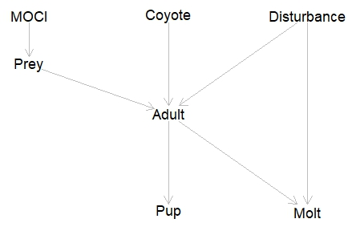

**Figure 2.** Directed Acyclic Graph (DAG) showing hypothesized relationships between covariates and harbor seal age classes. MOCI is the Multivariate Ocean Condition Indicator, Coyote is coyote presence, Disturbance is anthropogenic disturbances, and Prey is an unobserved variable influenced by MOCI. Adult populations should be related to pup counts and molt counts.

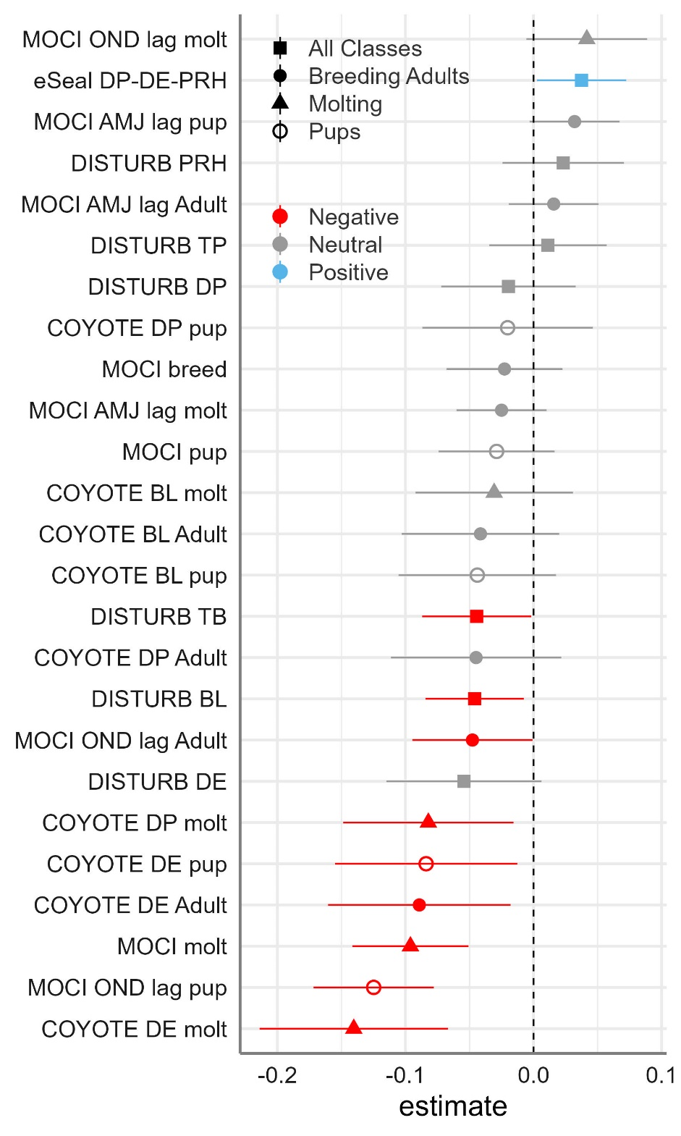

**Figure 3.** Covariate effects on harbor seal counts from 1997 – 2023.

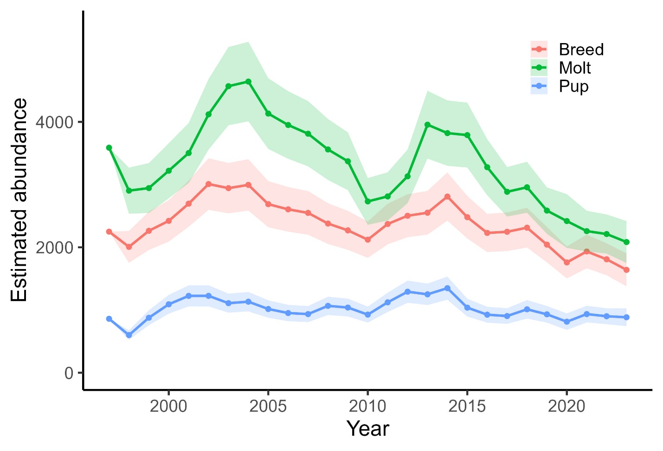

**Figure 4.** Total Population Size by age class: 1997 – 2023

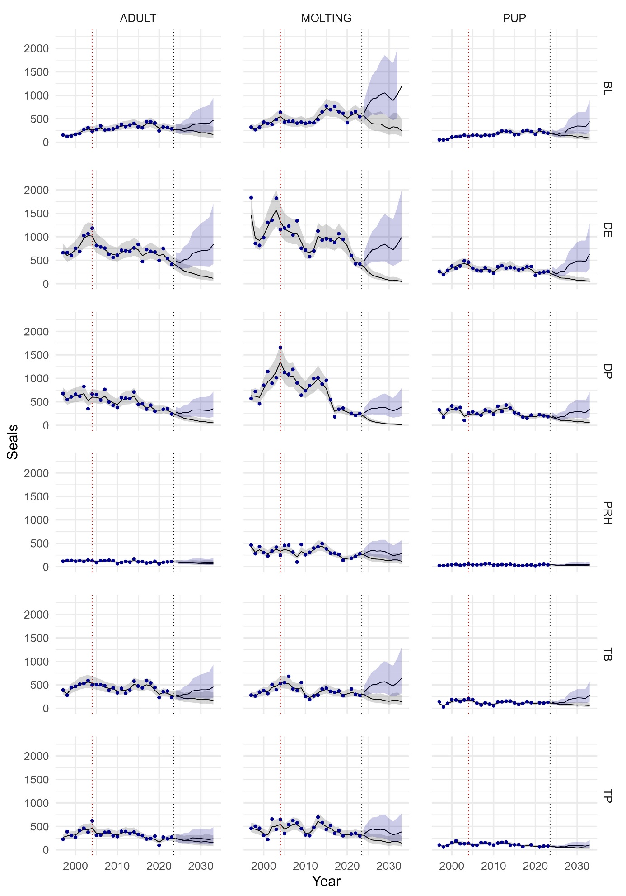

**Figure 5.** Site- and class-specific predictions of seal counts (1997-2023) and forecasts (2024-2033) under very good (blue) and very poor (grey) MOCI, coyote and anthropogenic disturbance impacts. Simulation parameters are in Table S3). Vertical red line at 2003-2004 shows change in population growth (Table 2) and vertical blue line separates model predictions (1997-2023) from forecasts (2024-2033). Blue points are model estimates and shaded areas represent 80% confidence intervals. Site abbreviations (BL, DE, etc.) are described in Table 1.

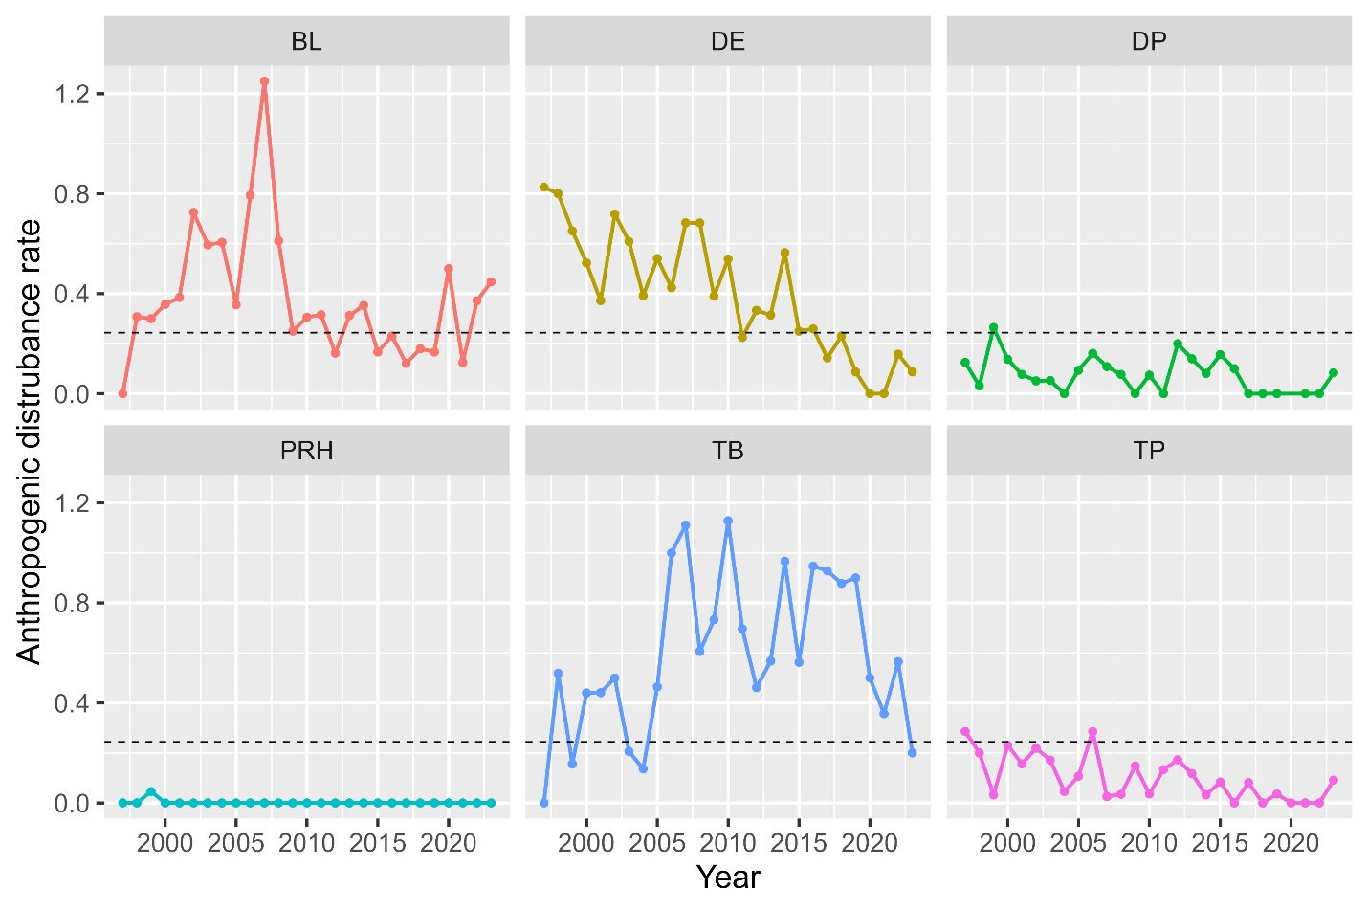

**Figure S1.** Human Disturbance rates per survey by site 1997-2023. BL: Bolinas Lagoon, DE: Drakes Estero, DP: Double Point, PRH: Point Reyes Headlands, TB: Tomales Bay, TP: Tomales Point.

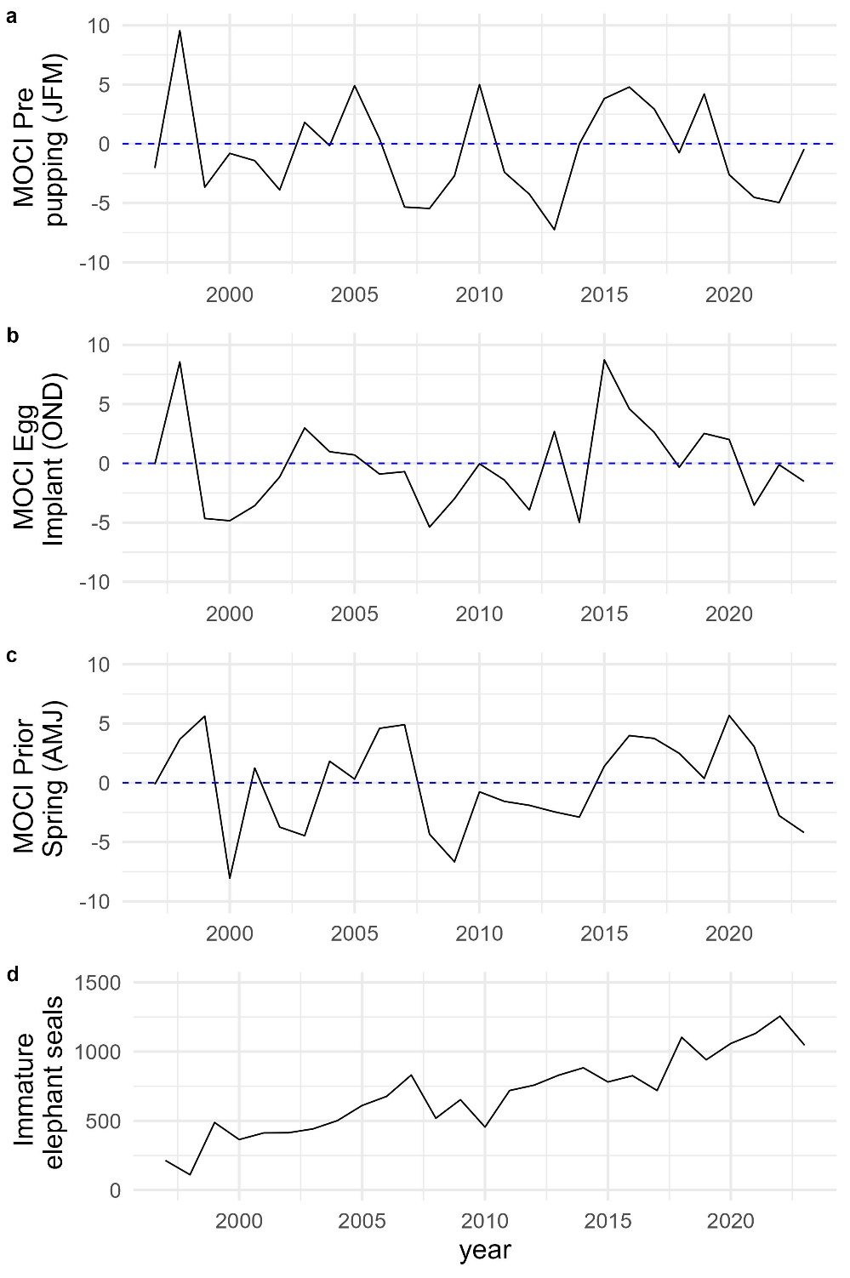

**Figure S2.** MOCI (a-c) and immature elephant seal (d) values over the study period. Details of MOCI calculations are described in the text. Positive MOCI values are generally warmer and less productive ocean conditions. Note in panel a (non-lagged MOCI values) that 1998, 2005, 2010 were ENSO years and a marine heatwave occurred during ~2014-2016.

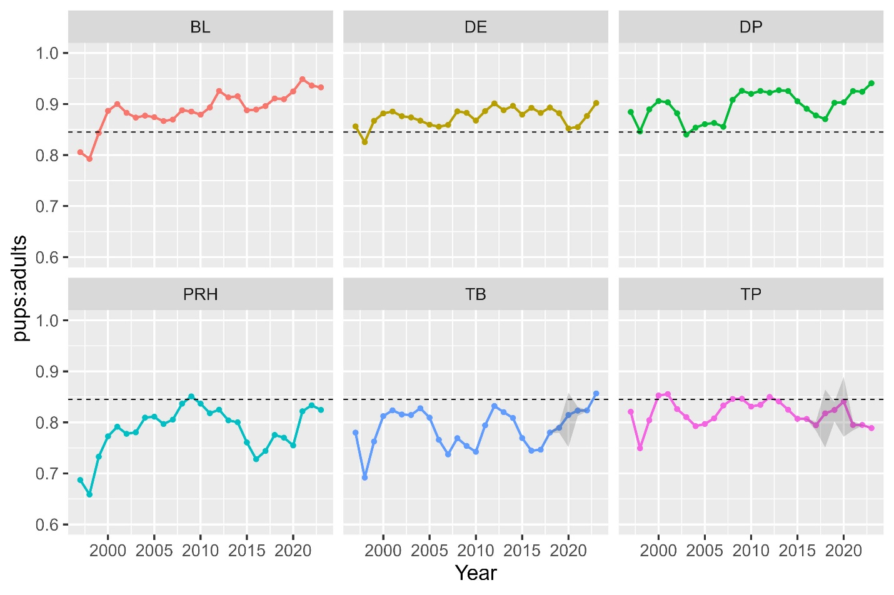

**Figure S3.** Ratio of pups to adults by site 1997 – 2023 calculated from predictions from the final MARSS model. BL: Bolinas Lagoon, DE: Drakes Estero, DP: Double Point, PRH: Point Reyes Headlands, TB: Tomales Bay, TP: Tomales Point. Horizontal line is the all site:year mean for reference.

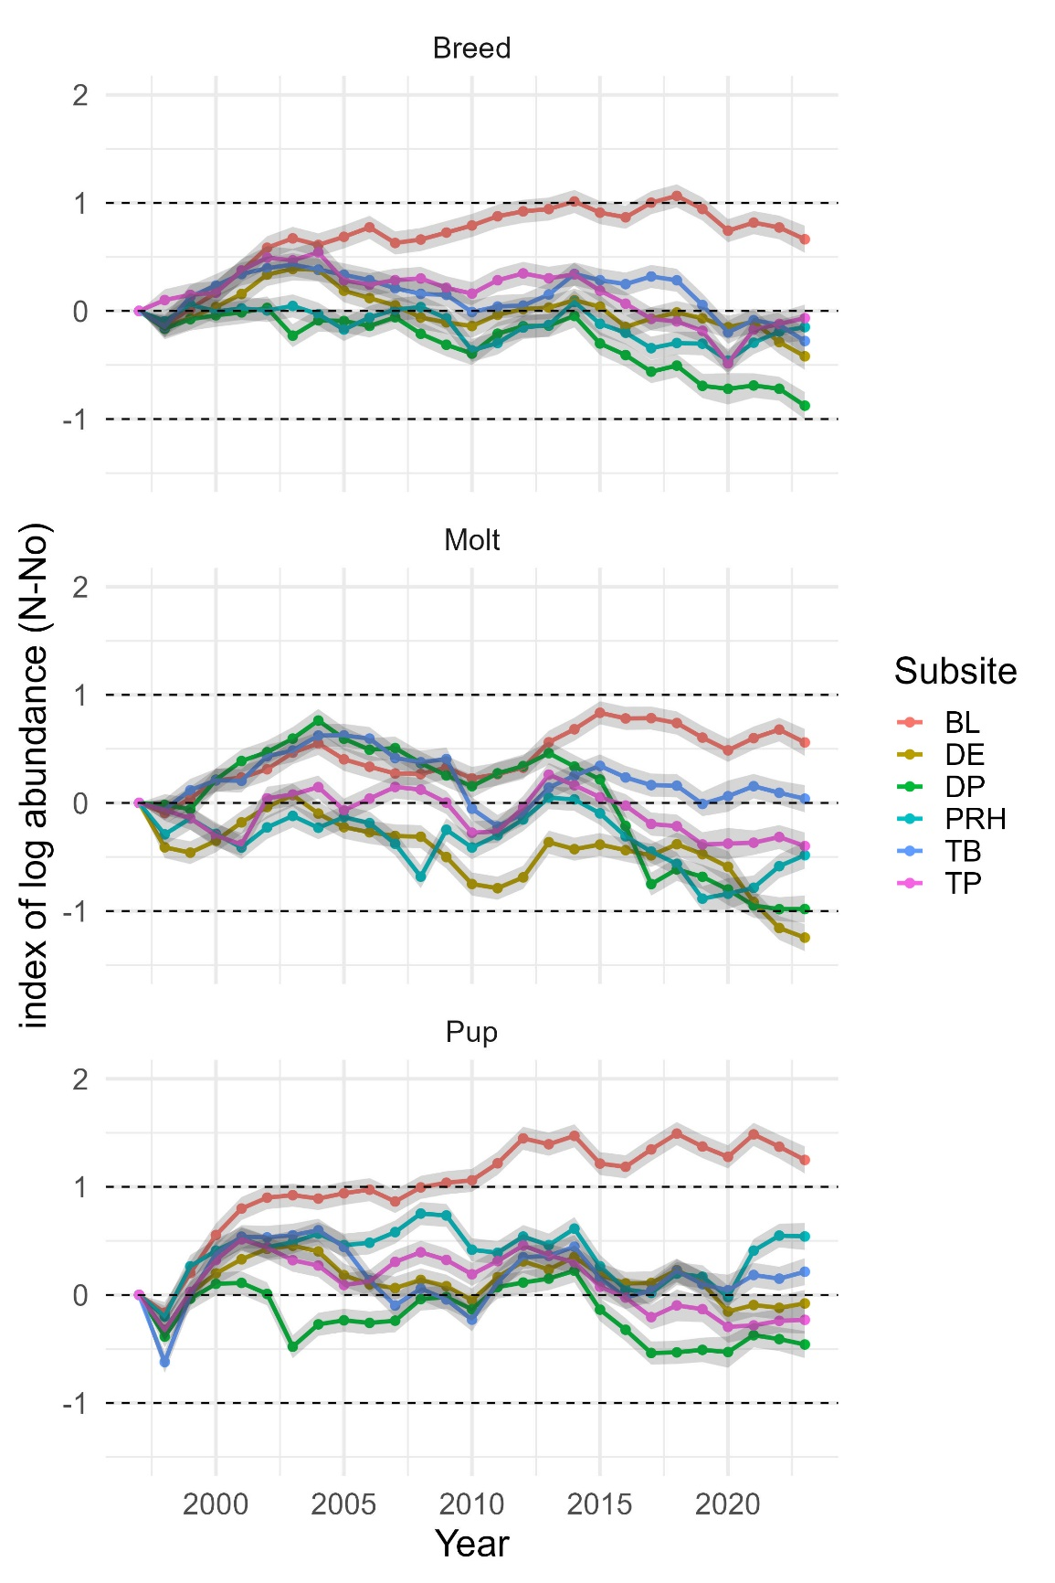

**Figure S4.** Change in log abundance by age class and site 1997 – 2023. BL: Bolinas Lagoon, DE: Drakes Estero, DP: Double Point, PRH: Point Reyes Headlands, TB: Tomales Bay, TP: Tomales Point.